Assignment No. 01: Networking Concepts



Spring 2025
CSE-303L Data Communication and Networks Lab

Submitted by: Naveed Ahmad
Registration No.: 22PWCSE2165
Class Section: B

“On my honor, as a student at the University of Engineering and Technology, I have neither given nor received unauthorized assistance on this academic work.”

Student Signature: ______________

Submitted to:

Dr. Ihsan Ul Haq
April 08, 2025

Department of Computer Systems Engineering
University of Engineering and Technology, Peshawar
Oodeded

Task 01:OSI MODEL:

- Which layer is responsible for end-to-end communication between running applications?
- 4

- Which layer is responsible for routing packets to the proper network?
- 3

- In the OSI model, which layer is responsible for encoding the application data?
- 6

- Which layer is responsible for transferring data between hosts on the same network segment
- 2

TASK 02: TCP/IP MODEL:

- To which layer does HTTP belong in the TCP/IP model?
- Application layer

- How many layers of the OSI model does the application layer in the TCP/IP model cover?
- 3

TASK 04: IP ADDRESS AND SUBNETS:

- Which of the following IP addresses is not a private IP address?
- 9.69.147.197
- Which of the following IP addresses is not a valid IP address?
- 192.168.305.19

TASK 05:UDP AND TCP:

- Which protocol requires a three-way handshake?
- TCP
- What is the approximate number of port numbers (in thousands)?
- 65

TASK 06:ENCAPSULATION:
- On a WiFi, within what will an IP packet be encapsulated?
- Frame
- What do you call the UDP data unit that encapsulates the application data?
- Datagram
- What do you call the data unit that encapsulates the application data sent over TCP?
- Segment

TASK 06:Telnet:
- Use telnet to connect to the web server on. MACHINE_IP What is the name and version of the HTTP server?
- lighttpd/1.4.63
- What flag did you get when you viewed the page?
- THM{TELNET_MASTER}

Task 08: Conclusion:

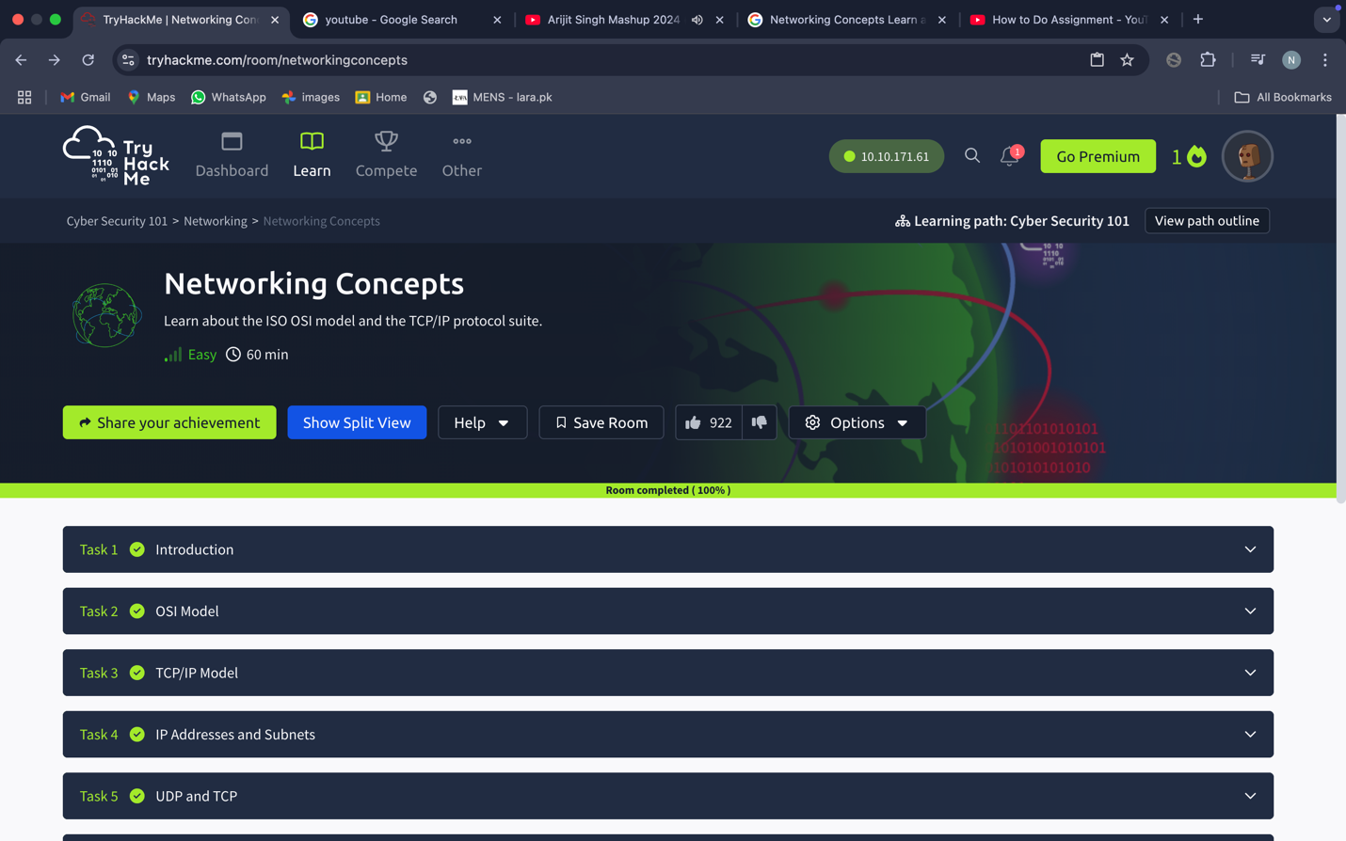

Competed Rooms 01:

